# Figure 7

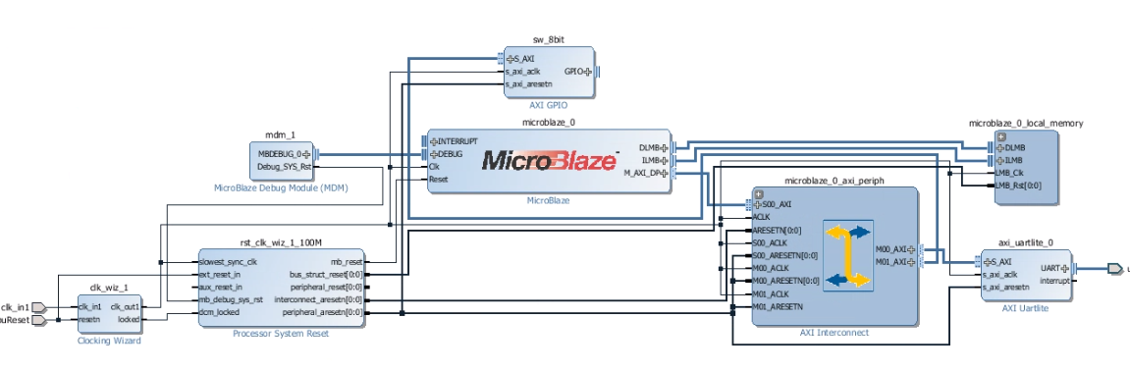

# Figure 9

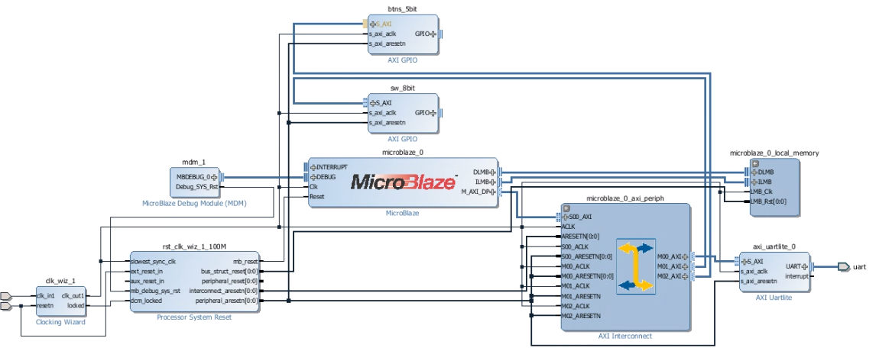

# Figure 11

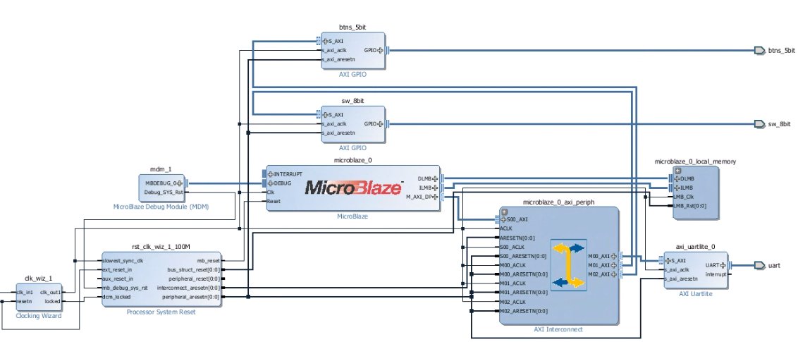

# Validation OK

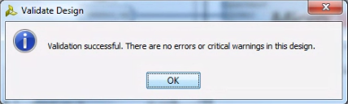

# Figure 13

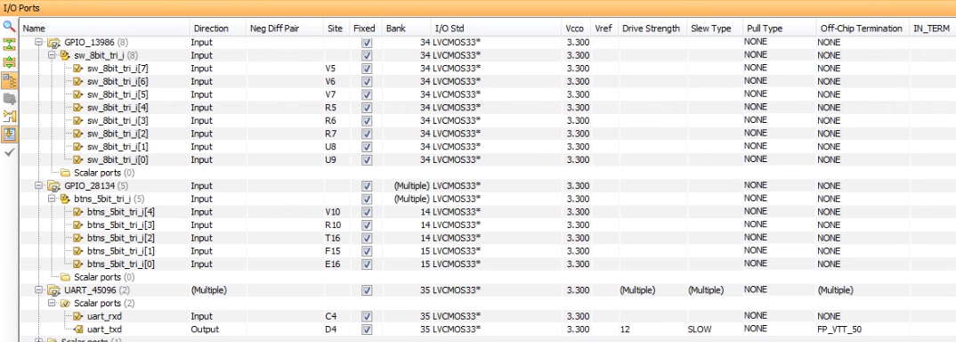

# Applicatie creëren

